
The Republic of Uganda

BUDAKA DISTRICT LOCAL GOVERNMENT
PROGRAMME FOR DISTRICT BARRAZA HELD AT IKI-IKI TOWN COUNCIL HEADQUARTERS
FRIDAY 17TH/JANUARY/2025
TIME | ACTIVITY
02:00-02:05 pm | Arrival and Registration
02:06-02:08 pm | National Anthem
02:09 -02:10 pm | Prayers
02:11-02:15 pm | Opening Remarks from the Master of Ceremony (District Planner)
02:16-02:30 pm | Communication from CAO
02:31-02:45 pm | Communication from LCV Chairperson
02:46-03:00 pm | Communication from RDC
03:01-03:40 pm | Communication from 3rd Deputy Prime Minister
03:41-05:30 pm | Open Discussions
05:31-05:50 pm | Closing Remarks
05:51-06:00 pm | Departure

The Republic of Uganda

BUDAKA DISTRICT LOCAL GOVERNMENT
MINUTES FOR THE DISTRICT BARRAZA HELD AT IKI-IKI TOWN COUNCIL HEADQUARTERS
FRIDAY 17TH/JANUARY/2025
MINUTE No | ISSUES/DETAILS | ACTION BY
01/BRZ/01/2025 | ARRIVAL AND REGISTRATION  All members registered on arrival | All to note
02/BRZ/01/2025 | NATIONAL ANTHEM  All members sung the National Anthem
03/BRZ/01/2025 | PRAYER  Prayer was led by Sheik Monda Hamudani
04/BRZ/01/2025 | OPENING REMARKS FROM THE MASTER OF CEREMONY (DISTRICT PLANNER)  The district Planner welcomed all members and thanked them for turning up for the occasion.  He informed members that the main purpose of the occasion was to have a cordial interaction between the 3rd Deputy Prime Minister, District staff, and community members. He encouraged all members to engage in open discussions, share information, and also seek clarifications where necessary.  He assured members that all their issues would be responded to by the 3rd Deputy Prime Minister and other key stakeholders present.  The master of ceremony also requested members to be orderly and also exhibit the highest level of discipline by respecting one another. | All to note
05/BRZ/01/2025 | COMMUNICATION FROM CAO  She welcomed all members to the function and thanked them for responding positively to the invitation.  She expressed her gratitude to all technical and political staff for their tireless hard work in relation to rendering good-quality services to communities. She encouraged members to keep the same spirit and also make improvements where necessary.  CAO emphasized that the needs of communities should always be prioritized.  CAO highlighted that Parish Development Model (PDM) is one of the strategies being used by the Government to improve the livelihood of the people in Budaka and Uganda at large.  She informed the public that the 4th disbursement of PDM funds was yet to be effected. She tasked PDM SACCO leaders and Parish chiefs to expedite the process of ensuring that SACCOS have fulfilled all the requirements before the next disbursement commences.  She called upon SACCO Leaders and Parish Chiefs to ensure that the right process is followed when selecting beneficiaries.  She further cautioned against extortion of money from beneficiaries. In this regard, CAO warned SACCO leaders and Parish Chiefs to avoid being tempted to ask for money from PDM Beneficiaries. This would attract a big penalty in case an individual is found guilty. She encouraged community members to report whoever extorts money from PDM beneficiaries.  CAO encouraged all groups that received Emyooga funds to ensure that they pay back.  CAO informed members that monitoring of all the projects is continuous including PDM. She tasked extension staff, technical staff at all levels, and political staff at all levels to interest themselves in monitoring government programs regularly. Consequently, this would lead to improved service delivery in the district.  CAO expressed the need to improve Tourism in the district. She tasked The Trade/Commercial Department to identify tourism sources. She further encouraged citizens to engage in various activities (such as art and Craft, cultural dances) that would promote tourism in the district.  CAO informed members that Nansanga and Mugiti Seed Secondary Schools were not yet handed over by the contractors because of some incomplete works; the schools would be commissioned after the handover. Construction of Kakule Seed School is ongoing. | All to note
06/BRZ/01/2025 | COMMUNICATION FROM LCV CHAIRPERSON  The Chairperson LCV welcomed all members to the Barraza.  He made the following remarks:-  Monitoring of government programs should be done routinely to ensure that government money is utilized profitably. He encouraged the public to also be involved in monitoring to ensure that government programs are executed efficiently.  He tasked the public to always give maximum respect to leaders.  He encouraged the congregation to work closely with their leaders to ensure that there is tight security in communities.  The Chairperson LCV reminded Sub County Chiefs and Town Clerks about their responsibilities. He emphasized that they should take control of their workstations.  He further encouraged teamwork amongst all workers. Particularly, he called upon staff to share resources, especially in times of crisis.  The Chairperson acknowledged the concern that some roads in the district were in dire need of maintenance and rehabilitation. He informed members that the district was planning to address some of the critical roads in the district.  He encouraged PDM beneficiaries to use the money for the intended purpose. He discouraged practices of extortion, particularly, he warned SACCO leaders and Parish Chiefs/Town Agents to desist from collecting money from PDM beneficiaries.  The Chairperson LCV thanked the Chief Administrative Officer for having accepted to host the 3rd Deputy Prime Minister to come and share as well as give solutions to pertinent issues affecting our communities.  The Chairperson expressed his gratitude to the community members for their continuous support to the NRM Government. He requested them to vote NRM, come 2026 general elections. The Chairperson assured the public that he is working tirelessly with his team to bring about significant improvement is service delivery. It was on this basis that he asked the public to vote him in the forthcoming elections.  The Chairperson LCV prayed for everyone to have good life so that they can accomplish their tasks. | All to note
07/BRZ/01/2025 | COMMUNICATION FROM RDC  The RDC thanked the 3rd Deputy Prime Minister for sparing her precious time to come to Budaka District. Particularly, he expressed his gratitude towards the Minister’s decision to come and listen as well as give responses to concerns raised by community members.  The RDC thanked the NRM government for providing security to citizens in Budaka and Uganda at large. However, he highlighted the need for more security enforcement in Budaka District. Particularly, he requested for a police Patrol vehicle to enhance police operations. In addition, he revealed that police officers were inadequate in relation to the population in the entire district. It was on this basis that the RDC requested the 3rd Deputy Prime Minister to advocate for an allocation of additional police constables to Budaka District.  The RDC acknowledged that fact that there were incidents of cattle theft in the district. He condemned the practice of theft. He called upon all members to safeguard themselves and their property. Specifically, he encouraged community members to form security teams at village level; these should protect village members and their property at all times.  He further emphasized that all members should be vigilant; they should report to police anyone they suspect to be a thief.  The RDC thanked the technical and political staff for ensuring a successful completion of disbursing PDM funds to beneficiaries. Particularly, special thanks went to CAO’s office, PDM core team at the District, Parish Chiefs/Town Agents, and Community Development Officers for tirelessly working around the clock to ensure that all beneficiaries receive the money.  He also thanked SACCO leaders for their commitment in ensuring that SACCOs have undertaken the required processes while getting ready to receive the money.  The RDC emphasized the need for cooperation and coordination amongst key stakeholders at all levels. In this regard, he encouraged Parish Chiefs/Town Agents to work closely with Community Development Officers to ensure that PDM affairs run smoothly in the district.  He also advised Parish Chiefs/Town Agents to always seek guidance and clarification on aspects that may seem unclear to them.  The RDC warned Parish Chiefs/Town Agents against extorting money from PDM beneficiaries. He assured them that whoever falls a victim of this practice will be arrested and judged in Courts of law. On the same note, he discouraged community members from giving money to whoever asks for it. In case it happened, the RDC advised community members to report such incidents to police or to RDC’s office.  The RDC assured members that his office will continue to ensure that there is good security in the district. He pledged to use the available resources and team to protect people and their property. | All to note
08/BRZ/01/2025 | COMMUNICATION FROM 3RD DEPUTY PRIME MINISTER  The 3rd Deputy Prime Minister thanked the district for giving her a warm welcome. She also thanked the district for organizing the Barraza. She informed members that her bosses (The President and The Prime Minister) had extended their warm greetings to the people of Budaka. She thanked them for supporting NRM Government, and encouraged them to continue supporting NRM.  The 3rd Deputy Prime Minister encouraged members to start registering for various posts. She also advised the public to ensure that they verify their details on the voter’s register.  The 3rd Deputy Prime Minister thanked the district for successfully completing the 3rd disbursement of PDM funds. She encouraged all beneficiaries to ensure that they used the money for the intended purpose.  The 3rd Deputy Prime Minister emphasized the need for the district to intensify monitoring and supervision of PDM programs. Typically, this would cases of misuse of the funds. It would also improve on productivity since farmers would be getting agricultural extension services.  The 3rd Deputy Prime Minister informed the public that she had come to share with them and respond to issues affecting normal service delivery in the district. She therefore encouraged all members to participate in this cordial interaction by raising or bringing forward their concerns. | All to note
09/BRZ/01/2025 | OPEN DISCUSSIONS  The Master of ceremony encouraged members to participate in an open discussion. In this cession, the public was given the opportunity to comment or raise their concerns, and these were responded to by the 3rd Deputy Prime Minister and other Technical staff present. Below is are some of the concerns that were raised for attention;  Kibeke from Kositi raised the concern that their cows were stolen by Ministry of Defense, and this happened in 5 sub counties  Gonsya complained about corruption. He alleged that there was high rate of corruption in Budaka DLG. He requested the 3rd Deputy Prime Minister to ask the President to send anti-corruption unit to Budaka.  One citizen raised the concern that the Board of Governors at Iki-Iki Secondary School sold the school bus due to corruption. He requested the 3rd Deputy Prime Minister to interne in this matter.  Mugali Martin complained that there was too much theft of cows in Iki-Iki.  Ali Sera expressed his dissatisfaction by saying that the road fund for Nansanga Sub county was very small. He requested the central government to increase on this fund. He further complained that Nansanga Sub county was denied electricity, yet it was on the plan for rural electrification.  Nalapa Moses complained that Parish Chiefs/Town Agents were depriving them of their PDM money. He requested that the money goes directly to their telephone lines.  The LCIII Chairperson of Kabuna Sub county complained that their transformer was taken by UMEME. He requested the 3rd Deputy Prime Minister and other key stakeholders to help them bring back the transformer.  One citizen requested the 3rd Deputy Prime Minister to reduce the age for people who benefit from grant for older persons. He suggested that the years should be reduced from 80 years to 60 or 70 years.  Bumba asked why police adopted the use of dogs to look for thieves, yet, once a thief is got (using a dog), police does not recognize a dog as sufficient evidence to imprison the victim.  Kapule notified the public by saying that the road connecting Budaka to Butebo was in a very bas condition. He requested the District to intervene as soon as possible to prevent accidents on this road.  Mwima Jamiru raised his concern by saying that there is unfairness in the process of generating lists for PDM beneficiaries. He revealed that they are sometimes asked to raise money before they are included on the lists.  Kalebo informed the 3rd Deputy Prime Minister that youth in Bugwere were not doing well. He requested the 3rd Deputy Prime Minister to extend their concern to the President so that youth in Bugwere are also thought about by the President.  Newuna Stephen demanded for electricity in Kotinyanga.  Katooko said that they needed space where they could orient people on loan services  Mugoda Benard said that they needed a staff house at Mivule Primary school. He further revealed that there were lower local govrnments in Budaka District that did not have Health Center threes. On this basis, he requested that a health center three is established in Kamonkoli Sub County. He further suggested government to always secure/buy land on which to build government institutions.  Wamubirigwe Akibari complained that they were not receiving road fund. He requested government to begin considering his sub county when allocating road fund.  Waira Wilson Duwa complained that they don’t have power in Budaka Sub county.  Mulefu informed the public that veterans (retired army individuals) were in bad condition. He requested for president’s assistance.  Musede Yokolamu complained that the Ministry of Agriculture was giving Budaka District fish to rear, yet his area is like a desert.  Musede Moses said that he wished Kameruka Sub county to be divided because it is too large.  Opajja Dyatumi Moses said that they needed motorcycles to run government programs smoothly.  Talibandula Moses said that some parishes are smaller than others, yet, they all receive the same amount of PDM funds. How can this issue be balanced?  RDC requested DPC s not to be transferred regularly because these frequent transfers distort smooth operations. He further acknowledged that it is true there was theft of cows in the district. He requested community members to work together towards solving this rampant issue.  The 3rd Deputy Prime Minister together with technical staff responded to all the concerns/issues that were raised by various people. The 3rd Deputy Prime Minister then thanked the public for being an active congregation. She encouraged the public to remain committed towards eradicating poverty by embracing and implementing government programs (such as PDM, Emyooga, YLP/UWEP, SEGOP, GROW, etc.). She further promised to carry people’s requests to the President and also share them in Parliament. In her conclusive remarks, she reminded the congregation to vote NRM in the forthcoming 2026 general elections. She then wished everyone good life and safe journey to their homes. | All to note
09/BRZ/01/2025 | CLOSING REMARKS  The Resident District Commissioner thanked the 3rd Deputy Prime Minister for coming to Budaka District. He thanked her for giving responses to the issues that were raised by the public. He requested the 3rd Deputy Prime Minister to fulfil her promises of sharing our concerns with the President and Parliament. | All to note
10/BRZ/01/2025 | DEPARTURE  All members Departed

PHOTOS FOR DISTRICT BARRAZA HELD AT IKI-IKI TOWN COUNCIL HEADQUARTERS
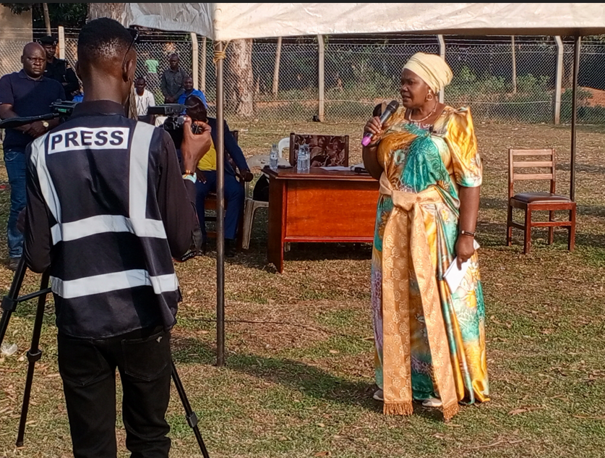
Figure 1: 3rd Deputy Prime Minister (Rukia Nakadama) giving her remarks during a Barraza at Iki-Iki Town Council Headquarters

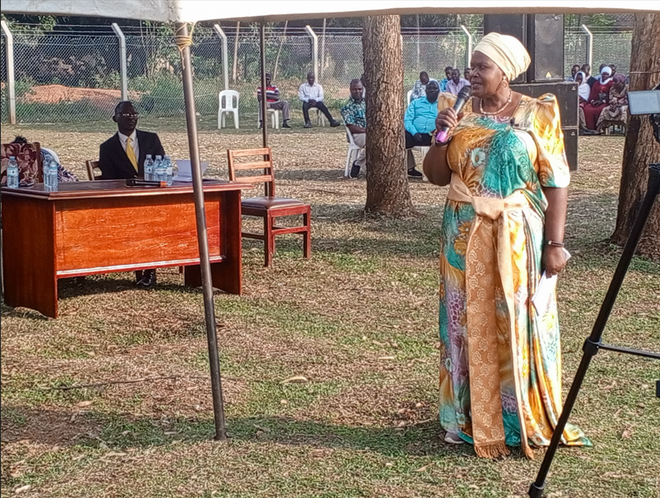
Figure 2: 3rd Deputy Prime Minister (Rukia Nakadama) responding to issues/concerns raised by the congregation during a Barraza at Iki-Iki Town Council Headquarters

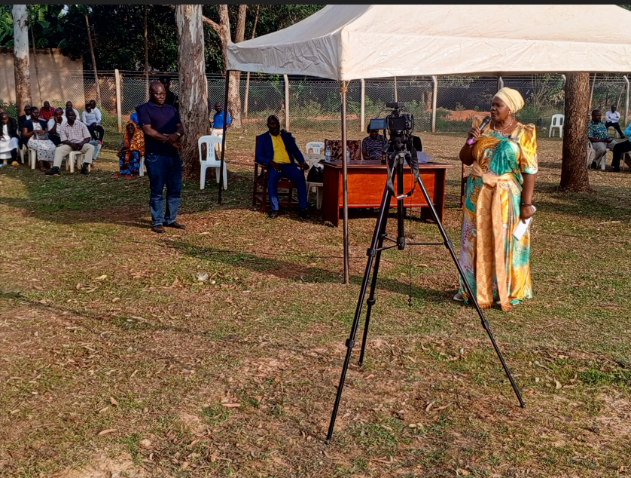
Figure 3: 3rd Deputy Prime Minister during a Barraza at Iki-Iki Town Council Headquarters

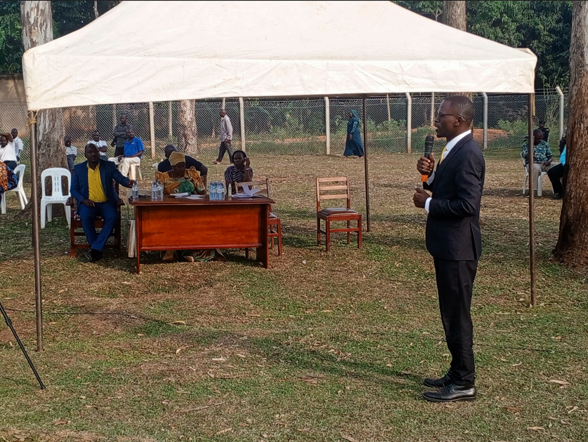
Figure 4: RDC giving his remarks during a Barraza at Iki-Iki Town Council Headquarters

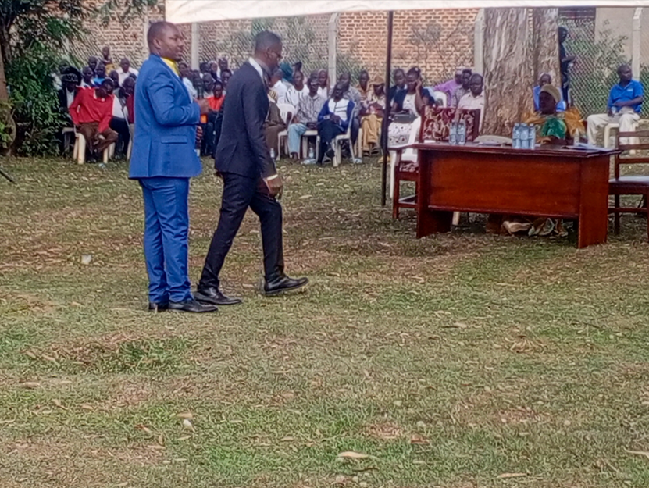
Figure 5: LCV Chairperson and RDC during a Barraza at Iki-Iki Town Council Headquarters

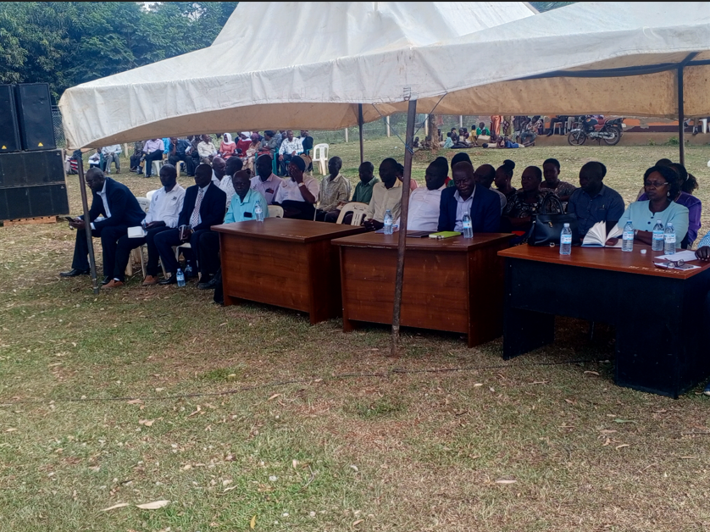
Figure 6: DCAO (on the right) and other Technical staff in attendance during Barraza at Iki-Iki Town Council Headquarters

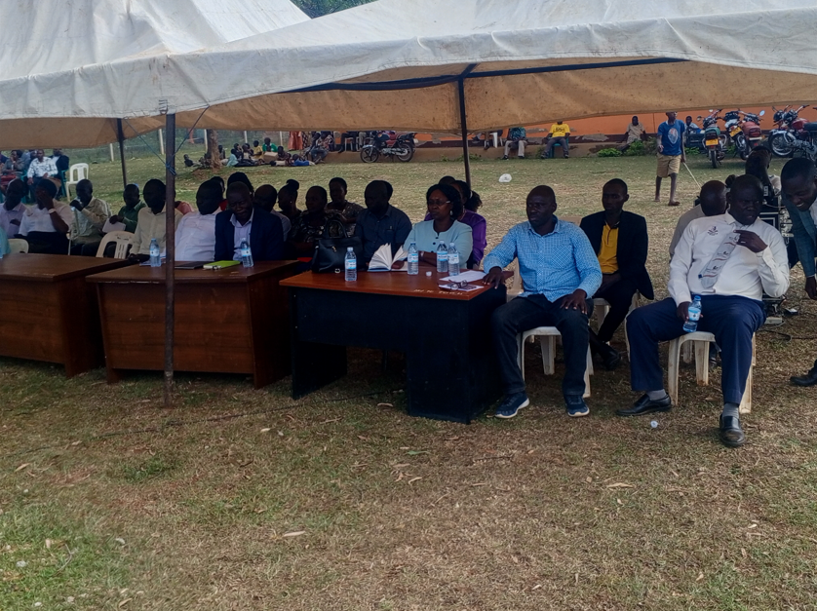
Figure 7: District Planner (1st on the right), DISO (2nd on the right) DCAO (3rd on the right) and other Technical staff in attendance during Barraza at Iki-Iki Town Council Headquarters

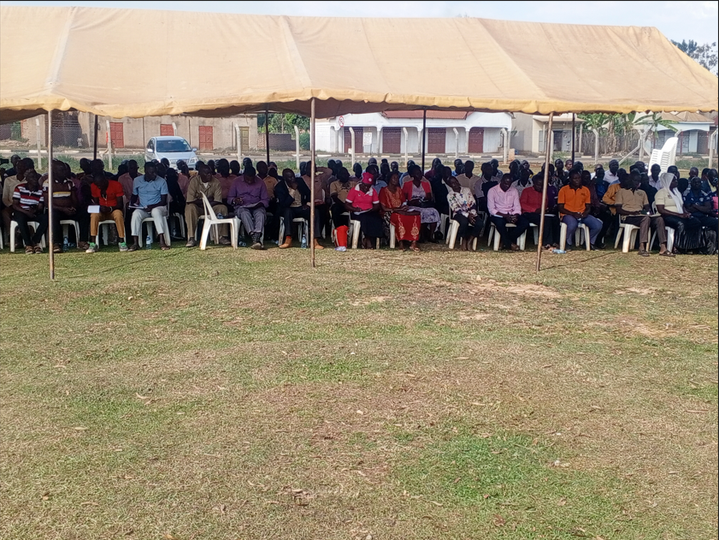
Figure 8: Community Members in attendance during Barraza at Iki-Iki Town Council Headquarters
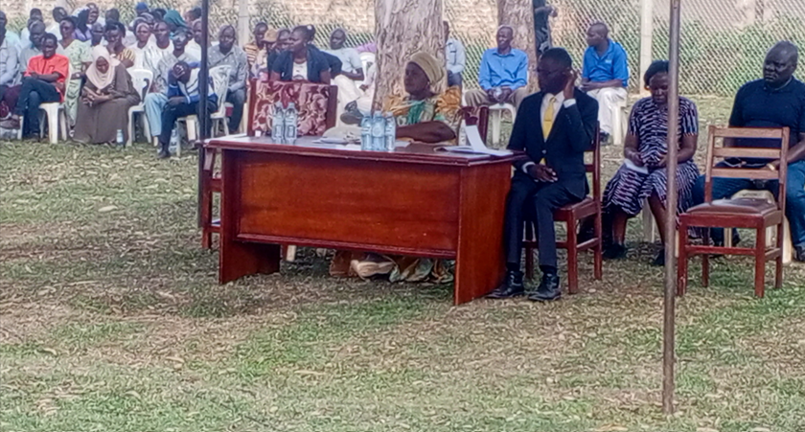
Figure 9: Community Members in attendance sited behind the 3rd Deputy Prime Minister and RDC during Barraza at Iki-Iki Town Council Headquarters

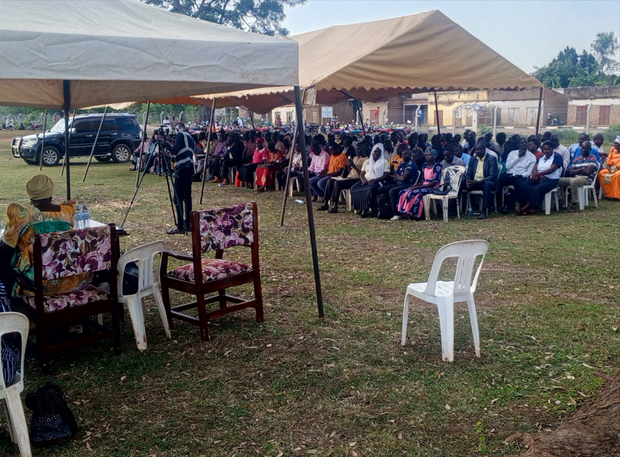
Figure 10: Community Members in attendance during Barraza at Iki-Iki Town Council Headquarters
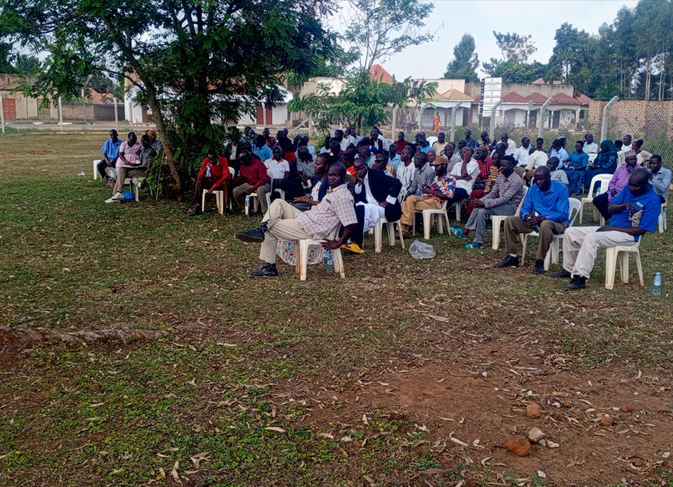
Figure 11: Community Members in attendance during Barraza at Iki-Iki Town Council Headquarters
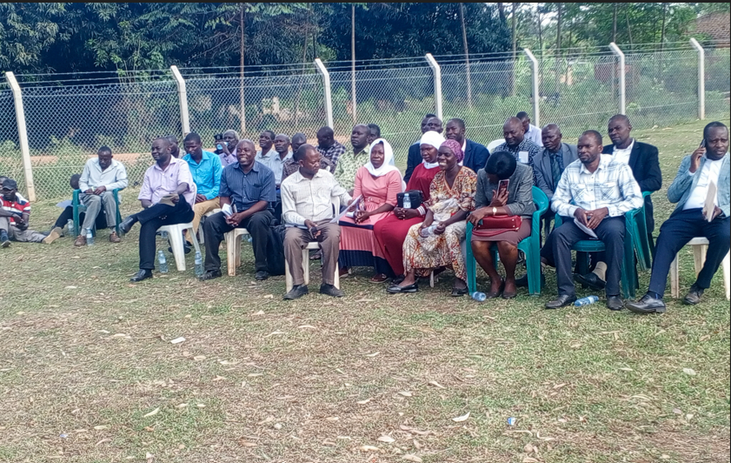
Figure 12: Some of technical staff sited together with community members during a Barraza at Iki-Iki Town Council Headquarters
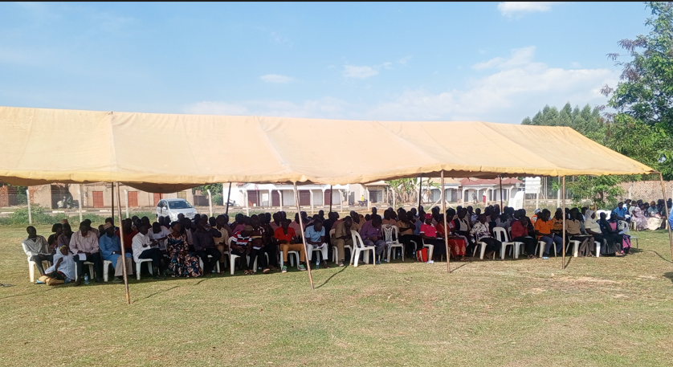
Figure 13: Community Members in attendance during Barraza at Iki-Iki Town Council Headquarters
Prepared by

Kiwolu Kenedy
Planner – Budaka DLG

